主题：天气预报

题型：流程图

The diagram shows the process of weather forcast by Australian Bureau of Meteorology

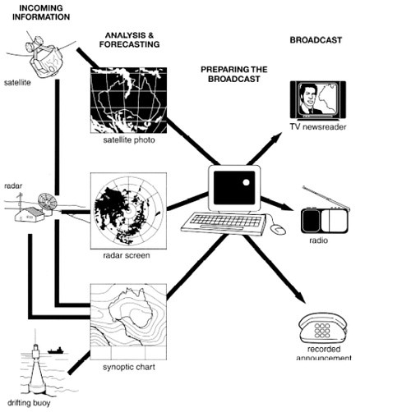

满分范文：  
The figure illustrates the process used by the Australian Bureau of Meteorology to forecast the weather.  
There are four stages in the process, beginning with the collection of information about the weather. This information is then analysed, prepared for presentation, and finally broadcast to the public.  
Looking at the first and second stages of the process, there are three ways of collecting weather data and three ways of analysing it. Firstly, incoming information can be received by satellite and presented for analysis as a satellite photo. The same data can also be passed to a radar station and presented on a radar screen or synoptic chart. Secondly, incoming information may be collected directly by radar and analysed on a radar screen or synoptic chart. Finally, drifting buoys also receive data which can be shown on a synoptic chart.  
At the third stage of the process, the weather broadcast is prepared on computers. Finally, it is delivered to the public on television, on the radio, or as a recorded telephone announcement.